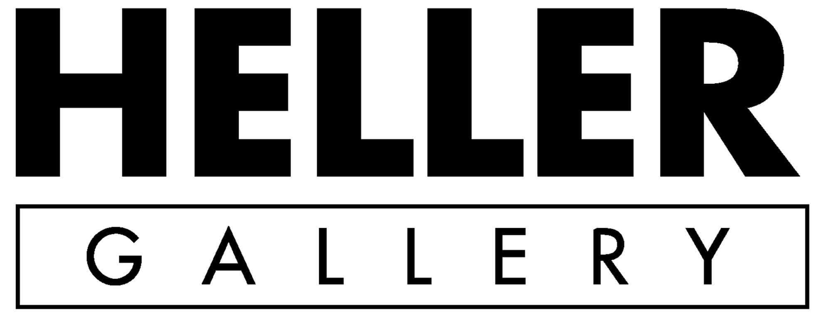

PRESS RELEASE For Immediate Release: January 19, 2021
Press Contact: Katya Heller
p: 212.414.4014
e:katya@hellergallery.com
_______________________________________________________________________________
NORWOOD VIVIANO | Re-Cast Cities
March 5 – May 1, 2021

New York -- Heller Gallery is pleased to present Re-Cast Cities, our fourth solo exhibition of work by American artist Norwood Viviano.

The first notion of the Re-Cast Cities works, emerged with a 2018 sculpture titled Recasting Detroit, in which a massive engine block supports the three-dimensional LiDAR scan-derived cityscape of downtown Detroit. Over the last two and a half years, Viviano has created a total of eight sculptures ‘merging urban landscapes with the symbols of industry that have fueled their booms, busts and builds.’ In addition to Detroit, they include the Dorflinger project (White Mills, PA), Houston, TX, Philadelphia, PA, Pittsburgh, PA, Portland, OR, New York, NY and Toledo, OH.

In an essay accompanying this body of work and the exhibition, writer and curator Sarah Darro, describes Vivano’s Recasting Houston as follows: ‘Houston’s craggy, serrated skyline rises out of a glossy obsidian oil drum in Norwood Viviano’s Re-Cast Cities series. The slick, glinting finish of the glass reads as though the entire form - the entire city - may be composed of crude oil itself. An infamously sprawling metropolis becomes bound, circumscribed by the raised edges of the industrial barrel that supports it. Despite this containment, Houston’s frenetic energy of unmitigated expansion is palpable. The scaled cartographic map, sourced from government LiDAR scans, is ruptured by a singular element - a steel ring cap. At this scale, the concave divot looks remarkably like a stadium arena that might house howling fans and sports teams named after titans of industry - the Oilers, perhaps. The exposed barrel cap has profound conceptual implications for the critical cartographic project being undertaken by Viviano. It does more than merely breach the map. Its presence allows the viewer to question the objectivity of cartographic space and to recognize the critical possibilities of experimental geography.’

After in-depth explorations of the past in his Mining Industries series, Re-Cast Cities embarks on ‘a radical reconsideration of cartography that inflects Viviano’s analysis of the rise and fall of American manufacturing with generative, experimental energy geared toward the possibilities of the future.’

Norwood Viviano’s work has been shown at the Venice Architectural Biennale (2014), Houston Center for Contemporary Craft, Houston, TX (2013); Museum of Fine Arts, Boston (2015), Frederik Meijer Gardens and Sculpture Park (2016), Bellevue Art Museum (2016), Renwick Gallery of the Smithsonian American Art Museum (2016) as well as at MOCA Jacksonville (2017). His work is represented in the collections of major museums including the Museum of Fine Arts Houston, Houston, TX; Museum of Glass, Corning, NY; Smithsonian American Art Museum, Renwick Gallery, Washington, D.C., Grand Rapids Art Museum, Grand Rapids, MI; deYoung Museum, San Francisco, CA; Chrysler Museum of Art, Norfolk, VA; Museum of Decorative Arts, Prague, Czech Republic; Shanghai Museum of Glass, Shanghai, China; Speed Art Museum, Louisville, KY; John Michael Kohler Arts Center, Sheboygan, WI and the Museum of Glass, Tacoma, WA.

