PRESS RELEASE For Immediate Release: April 23, 2015
Press Contact: Katya Heller p: 212.414.4014
e: katya@hellergallery.com

JASON MILLER | JUNGLE
May 8 – 30, 2015
Reception for the artist: Thursday, May 7, 6-8pm

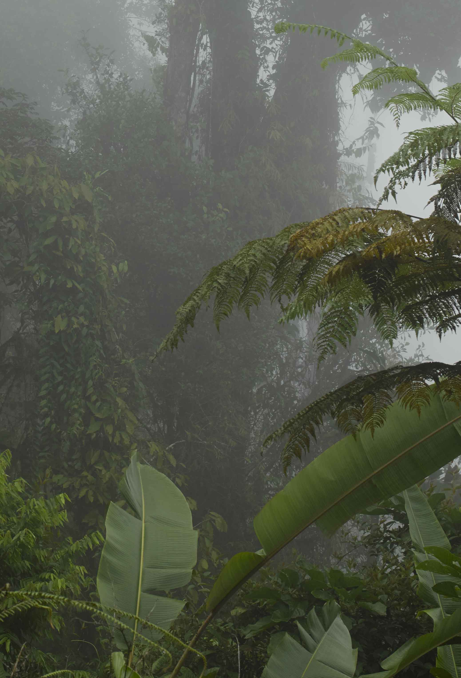
Heller Gallery is pleased to present Jungle, our first solo exhibition of new work by American designer and artist Jason Miller.

Miller’s designs draw on everyday aspects of contemporary American culture. His suburban upbringing informs the elegant, historically rich work for which he is known. His mirrors, whose surfaces often recall a painted landscape and sculptural lighting fixtures, blur the boundary between art and design. With beauty and wit, his objects are as much contemporary design as conceptual art

The lush landscape of the Central American jungle is the theme of this exhibition. Miller describes the Jungle as ‘a series of frighteningly steep mountains covered by mist and seemingly held together by a tangled mass of vegetation. The density and sameness render it almost monochromatic until one stumbles on to an impossibly hued flower hanging from nowhere as if floating. The nineteenth century painter, Martin Johnson Heade captured this beautifully in his paintings from Brazil and Nicaragua. Jungle is an attempt to do the same in mirror and light.’ The exhibition includes new large-scale mirrors and a chandelier.

Jason Miller received an MFA in painting, but has made his greatest mark as a designer. He is the founder of Jason Miller Studios and the contemporary lighting company Roll & Hill. He has exhibited internationally, has been featured in numerous publications. In 2010 he was named ‘Designer of the Year’ by the Brooklyn Museum. His work is part of the permanent collection of the Museum of Arts and Design, New York, NY; the Corning Museum, Corning, NY and the Brooklyn Museum, Brooklyn, NY.

An opening reception for the artist will take place at Heller Gallery, on Thursday, May 7, 2015 from 6-8pm.

