PRESS RELEASE For Immediate Release
Contact: Katya Heller
e: katya@hellergallery.com
p: 212.414.4014
________________________________________________________________________________________

LINO TAGLIAPIETRA | Journey
October 8 – November 6, 2019

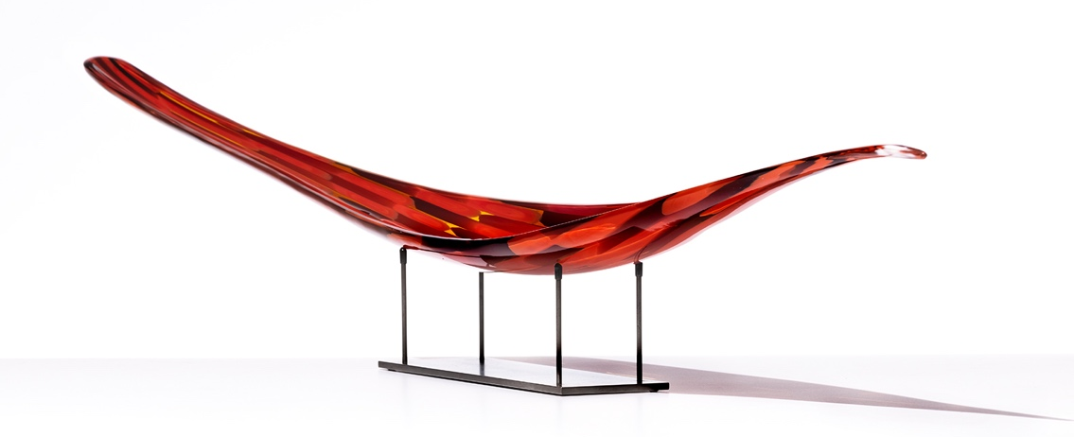
ENDEAVOR, 2017, glass, 5 ¾ x 65 ½ x 5 ½ in. (glass only)

New York, NY – Heller Gallery presents Journey, an exhibition honoring the octogenarian Italian maestro, Lino Tagliapietra, who recently announced his retirement from active glassblowing. The exhibition reflects on twenty years of Tagliapietra’s practice and focuses on prime examples of new and archived works. Tagliapietra, who just celebrated his 87th birthday, has spent an unprecedented 75 years practicing his art. Douglas Heller, a leading authority on contemporary glass who helped establish the US market for this medium, curated the exhibition.

Along with the exhibition, Heller Gallery will be screening Lino Tagliapietra: The Making of a Maestro, a one-hour documentary on the history of maestro glass artist, Lino Tagliapietra narrated by the British-American actor Alfred Molina.

Tagliapietra’s glass forms are firmly based in the 20th century Italian design idiom. His pieces are characterized by bold colors and exuberant patterning, which ranges from murine reminiscent of miniature fireworks displays to the newest lozenge shaped ‘aquilone’ (or kite) murine. They are a literal embodiment of the artist’s extraordinary and ongoing creative vitality and experimental nature. Each piece is a de-facto encyclopedia of classical Muranese glassmaking techniques, from which Tagliapietra chooses with ease. His vessels radiate vibrant optimism and effortless virtuosity.

Lino Tagliapietra started at the age of twelve as an apprentice in a glass factory on his native island of Murano. He earned the title of maestro vetraio - master glassmaker - at 21 and in the late 1970s set off to pursue the path of a studio artist. After 75 years of working in the hotshop, the material remains magical to him.

Arguably the greatest ambassador of Italian glassmaking in the service of art, Tagliapietra has been a most sought-after teacher, collaborator and consultant to artists, architects and designers working with glass worldwide. Lino broke open the treasure trove of Italian glassblowing techniques and taught them with courage and generosity to generations, changing the world of blown glass forever. Recounting his first experience of teaching in the United States: "The boldness was so new to me … on the one hand, it was a shock—the lack of a cultural base, the absence of traditions. But on the other hand, it was exhilarating—the lack of restraint in the process, the exciting results."

The recipient of numerous awards, his work is represented in the collections of more than 50 museums internationally including the Metropolitan Museum of Art, New York, USA; the Victoria and Albert Museum, London, UK; the Musée des Arts Decoratifs, Paris, France and numerous other public and private collections worldwide.

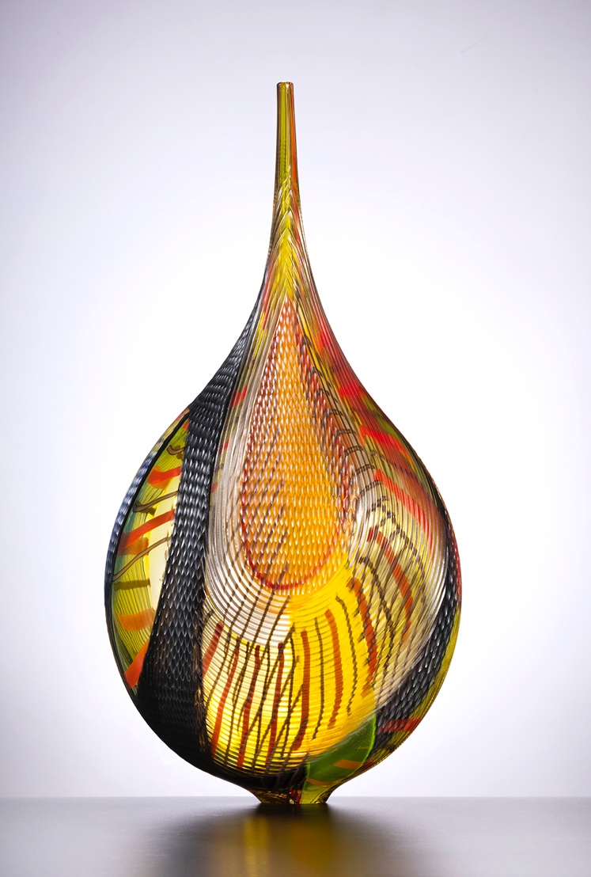
MANDARA, 2006, glass, 23 ¾ x 11 ¾ x 5 ¾ in.

Heller Gallery, founded in 1973 in New York, provides a curated platform for studio artists whose practice incorporates glass and whose work with the material broadens the horizons of contemporary culture. We identify, nurture and represent emerging artists as well as prominent international masters.
Numerous artworks have entered preeminent public collections as a direct result of Heller Gallery's exhibitions and advocacy. New York's Metropolitan Museum of Art and Museum of Modern Art have acquired works from the gallery as has The Corning Museum of Glass, The Los Angeles County Museum of Art, The Museum of Fine Arts, Houston, and numerous museums worldwide, including Victoria & Albert Museum, Musée des Arts Décoratifs de Louvre, and Hokkaido Museum, among others.

